 CHEMICAL ENGINEERING TRANSACTIONS  VOL. xxx, 2026 | A publication of  
The Italian Association
of Chemical Engineering
Online at www.cetjournal.it

Guest Editors: Laura Capelli, Marzio Invernizzi, Selena Sironi
Copyright © 2026, AIDIC Servizi S.r.l.
ISBN 979-12-81206-xx-x; ISSN 2283-9216

A Research–Industry Collaborative Approach to Standardized Electronic Nose Classification
E. Massera*a, E. Caccavoᵇ, A. Carrafielloᵇ
ªENEA – Italian National Agency for New Technologies, Energy and Sustainable Economic Development, Portici Research Center, Portici (NA), Italy
^{b}Neotes S.r.l., Environmental Analysis Laboratory, Battipaglia (SA), Italy
ettore.massera@enea.it
Odour pollution has gained increasing relevance, prompting the development of technical standards to harmonize measurement methodologies. While dynamic olfactometry remains the regulatory reference, recent advances enable the application of electronic noses for continuous environmental monitoring; however, calibration procedures are still often dependent on human sensory panels, with limitations in cost, repeatability, and operational feasibility.
A collaborative activity between ENEA and Neotes S.r.l. was established to validate an electronic nose for direct field use through a standardized laboratory-based approach. The emerging IEEE SA P2520.1 protocol introduces a training and calibration methodology based on predefined chemical classes, allowing full instrumental standardization without the involvement of human assessors and within a broader framework aimed at harmonizing e‑nose applications.
Preliminary validation was conducted on a GC‑IMS system using isobutene, isopropanol, and acetone under controlled environmental conditions. Differentiation, recognition, and quantification performance levels were assessed by varying concentrations and environmental parameters. The results demonstrate the applicability of the P2520.1 procedure to commercial devices and its capability to support reproducible odour classification. This approach represents a promising step toward internationally shared standards for instrumental olfactory measurement, supporting continuous monitoring and early detection of odour‑related critical events.
  - Introduction
The collaboration between ENEA and Neotes S.r.l. was established within the framework of industrial development and technology transfer activities aimed at advancing low‑TRL sensor technologies toward operational maturity. In this context, the joint effort addresses a well‑recognized gap in artificial olfactometry, namely the absence of standardized and reproducible criteria for the performance evaluation of electronic noses. While several instrumental solutions are currently available, objective procedures for classification, calibration, and comparability of different devices remain insufficiently defined, limiting their reliable adoption in regulatory and industrial environments.
The proposed approach builds on the concept of functional classification of electronic noses according to increasing performance levels, namely the ability to detect the presence of an odour, to distinguish between different odorous stimuli, and to quantify odour intensity through instrumental responses. Achieving the highest performance level requires controlled generation of reference gaseous mixtures, repeatable measurement protocols, and objective data analysis procedures capable of ensuring reproducibility and traceability. By combining laboratory‑based standardization with industrial validation, the collaboration aims to demonstrate the feasibility of transferring advanced sensor characterization methodologies from research environments to practical applications, in alignment with emerging international standardization efforts such as IEEE SA P2520.1.
    - Odour pollution and regulatory context
Odour pollution has become an increasingly relevant environmental issue, particularly in proximity to industrial plants, waste treatment facilities, and intensive agricultural activities. Public concern and regulatory scrutiny have grown accordingly, leading to the development of specific technical standards aimed at ensuring objective and comparable odour measurements. At the European level, EN 13725 defines dynamic olfactometry as the reference method for the determination of odour concentration, based on the sensory response of a trained human panel.
Despite its regulatory relevance, dynamic olfactometry presents intrinsic limitations that restrict its applicability to continuous monitoring scenarios. The method is discontinuous by nature, involves significant operational costs, and is affected by inter‑ and intra‑panel variability. These aspects limit its effectiveness for real‑time control, early warning applications, and long‑term surveillance of odour emissions, highlighting the need for complementary instrumental approaches.
    - Electronic noses for environmental monitoring
Electronic noses and instrumental odour monitoring systems (IOMS) have emerged as promising tools for environmental applications, owing to their ability to operate continuously and to provide rapid responses to changes in odour load. Such systems are increasingly deployed for early detection of odour‑related events, process monitoring, and support to environmental management strategies.
However, the broader adoption of electronic noses in regulatory and industrial contexts is still constrained by the lack of shared criteria for performance evaluation. Calibration and validation procedures often rely on sensory data, and different devices are characterized using non‑uniform methodologies, resulting in limited comparability between instruments. Addressing these issues requires standardized, fully instrumental frameworks that define measurable performance levels and enable reproducible classification of electronic nose capabilities.
    - Research–industry framework and standardization need
In this context, the collaboration between ENEA and Neotes S.r.l. represents a research–industry effort aimed at bridging the gap between laboratory‑scale sensor development and operational deployment. The joint activity focuses on advancing low‑TRL electronic nose technologies toward practical applications through standardized characterization procedures. Central to this approach is the concept of functional classification of electronic noses according to increasing performance levels, namely the ability to detect, distinguish, and quantify odorous stimuli.
The present work aligns with international standardization efforts, particularly the IEEE SA P2520.1 framework, which proposes instrumental training and calibration methods based on predefined chemical classes. The objective of the study is to validate the applicability of this standardized approach to a commercial GC‑IMS system, demonstrating its potential to support objective, reproducible, and transferable electronic nose classification.
  - Standardization Framework for Electronic Nose Classification
    - Performance levels in artificial olfactometry
Artificial olfactometry requires objective criteria to evaluate the capability of electronic noses across different application scenarios. A functional classification based on performance levels provides a structured approach to describe instrumental behaviour in terms that are conceptually consistent with sensory odour assessment. Within this framework, three progressive performance levels can be identified: differentiation, recognition, and quantification.
Differentiation refers to the ability of the instrument to discriminate between different odorous stimuli, regardless of their specific identity. Recognition extends this capability by enabling the association of sensor responses with predefined chemical classes. Quantification represents the most advanced level, requiring a reproducible relationship between sensor output and odour or chemical concentration. Defining these levels in measurable and repeatable terms is a prerequisite for standardized instrumental evaluation.

    - IEEE SA P2520.1 overview
The IEEE SA P2520.1 draft standard has been developed to address the lack of harmonized procedures for electronic nose performance assessment. The framework introduces a structured methodology for training and calibration based on predefined chemical classes, enabling fully instrumental evaluation without the involvement of human sensory panels. Tests are organized into progressive levels that correspond to increasing performance requirements, from robustness assessment to discrimination and quantification.
By adopting standardized gas mixtures, controlled environmental conditions, and objective performance metrics, the P2520.1 framework supports reproducibility and comparability across devices and laboratories. The approach is designed to be technology‑agnostic, allowing its application to different sensor architectures and analytical platforms, including GC‑IMS‑based systems.
    - Alignment with industrial requirements
Standardized electronic nose classification addresses key requirements for industrial and environmental monitoring applications, including repeatability of measurements, comparability between instruments, and reliability under varying operational conditions. These aspects are essential for integrating instrumental odour monitoring into self‑control strategies and for supporting regulatory decision‑making.
By providing objective performance benchmarks, standardized classification frameworks enable both manufacturers and end‑users to assess instrument suitability for specific applications. In this context, instrumental approaches based on international standards have the potential to complement established sensory methods, contributing to a more robust and scalable odour monitoring paradigm.
  - Materials and Methods
    - Instrumentation
The Equipment Under Test (EUT) was a gas chromatography–ion mobility spectrometry (GC‑IMS) system manufactured by GAS (Dortmund, Germany). The instrument is designed for semi‑analytical applications, allowing the acquisition of characteristic odour fingerprints, chemical discrimination, and compound quantification. The GC‑IMS couples a Restek MXT‑5 capillary column with an ion mobility spectrometer operated under atmospheric pressure conditions.
All laboratory tests were performed at the ENEA Research Center of Portici (Italy), in a dedicated facility equipped for controlled sensor characterization. The instrument was operated using high‑purity nitrogen (grade 5.0) as carrier gas in order to maximize the dynamic range of the IMS signal. Calibration and routine maintenance were carried out following the manufacturer’s recommendations, using certified gas standards consistent with the IEEE SA P2520.1 draft protocol.
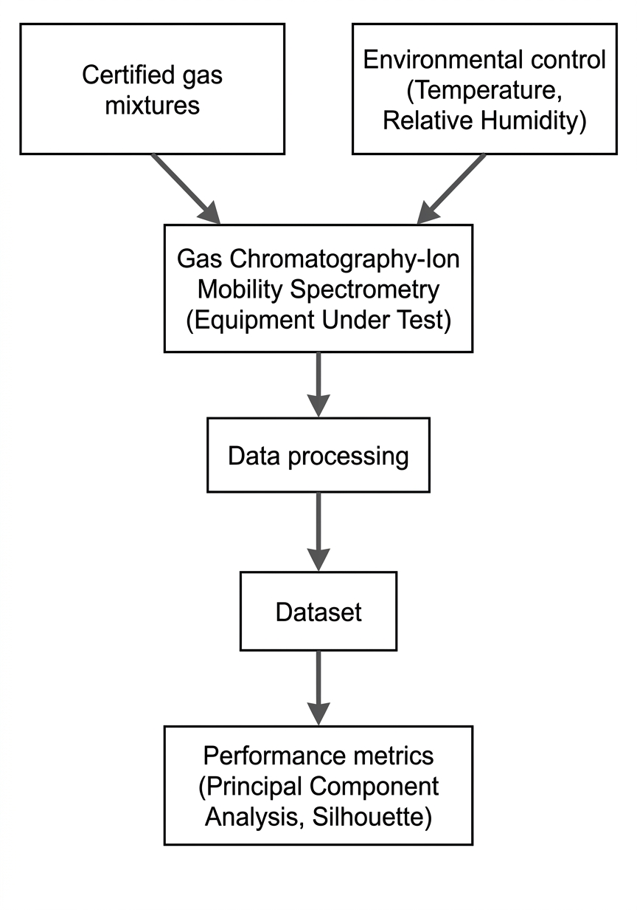
Figure 1: Schematic overview of the experimental setup and data workflow adopted for standardized electronic nose classification. Certified gas mixtures are generated under controlled temperature and humidity conditions and delivered to the GC‑IMS equipment under test. Instrumental responses are processed to build a dataset used to evaluate differentiation, recognition, and quantification performance according to the IEEE SA P2520.1 framework.
The overall experimental setup and data processing workflow are illustrated in Figure 1, highlighting the generation of controlled gas mixtures and the subsequent analytical pipeline used for performance evaluation.
    - Reference chemical compounds
The experimental activity focused on Group 1 reference compounds as defined in draft version 20.2 of the IEEE SA P2520.1 standard. Three certified gas mixtures were selected to represent chemically distinct odorous substances:
- isobutene (C₄H₈),
- isopropanol (C₃H₈O),
- acetone (C₃H₆O).
Each compound was supplied in synthetic air with certified concentration and traceability documentation provided by the manufacturer. The selection of these compounds was intended to test the electronic nose performance across chemically diverse classes.
    - Gas sample generation and environmental control
Gas samples were generated using a Gas Chemical Sample Generation System (GCSGS) developed by ENEA. The system consists of an airtight, electropolished stainless steel chamber housed in a thermostated enclosure to ensure thermal stability. Artificial atmospheres were obtained by mixing certified gas streams with synthetic air through high‑precision mass flow controllers, allowing accurate control of chemical concentration, temperature, and relative humidity.
The temperature and humidity of both the test chamber and the delivered gas sample were continuously monitored using calibrated sensors. Humidity control was achieved by combining dry and humidified carrier gas streams. The overall uncertainty in gas concentration was primarily determined by the accuracy of the certified gas bottles and the full‑scale range of the mass flow controllers, whose tolerance did not exceed ±1 % of full scale.
    - Experimental protocol and test levels
Measurements were conducted according to the testing philosophy defined in the IEEE SA P2520.1 draft standard. The protocol is structured into three progressive performance levels:
- Level 1 (LVL1): robustness and repeatability assessment under varying environmental conditions,
- Level 2 (LVL2): discrimination and recognition capability among different chemical classes,
- Level 3 (LVL3): quantification accuracy under controlled and varying conditions.
Gas samples were delivered to the GC‑IMS using “Method 2” as defined in the draft standard. Tests were performed under nominal reference conditions (25 °C and 40 % relative humidity) as well as under systematically varied temperature and humidity levels. Gas concentrations were generated by diluting certified gas standards in synthetic air through high‑precision mass flow controllers (±1 % full‑scale accuracy). The investigated concentration ranges were selected based on certification limits and instrumental sensitivity, ensuring reliable detection across all tested compounds. The reference concentration for the three levels is 100 ppm for the three chemical compounds. A 24 h warm‑up period was applied prior to data acquisition to ensure instrument stability.
    - Data acquisition and performance metrics
Raw measurement files generated by the GC‑IMS were processed using VOCal software for feature extraction. From the two‑dimensional spectral patterns, regions of interest were selected to compute quantitative descriptors such as signal area and intensity‑based parameters. The resulting dataset was enriched with metadata related to environmental conditions and nominal gas concentrations.
Performance evaluation was carried out using multivariate statistical indicators consistent with the IEEE SA P2520.1 framework. Principal component analysis was applied to assess clustering behaviour, while the silhouette coefficient was used as the main metric for differentiation and recognition tests. For quantification assessment, the mean absolute percentage error was adopted to evaluate agreement between nominal and instrument‑estimated concentrations.
Additional methodological details, including the full experimental setup, measurement protocols, and extended performance datasets, are documented in a technical report made publicly available through Zenodo (DOI: https://doi.org/10.5281/zenodo.19451759).
  - Results and Discussion
    - Differentiation capability
Quantitative evaluation of differentiation performance was supported by principal component analysis (PCA) and silhouette coefficient values, which were consistently positive under all tested conditions, confirming well‑defined clustering and effective discrimination among chemical classes.
The differentiation performance of the GC‑IMS system was evaluated according to Level 1 (LVL1) criteria defined in the IEEE SA P2520.1 framework. Under standard conditions, the instrument generated stable and well‑separated response patterns for the three reference compounds, demonstrating high repeatability of the measured odour fingerprints.
When temperature and humidity were varied independently and in combination, the system maintained a clear separation between chemical classes, indicating a robust response to environmental perturbations. The observed clustering behaviour confirms that the differentiation capability is primarily governed by intrinsic chemical selectivity rather than by environmental fluctuations. These results support the suitability of the tested GC‑IMS architecture for baseline odour discrimination tasks in both laboratory and operational scenarios.
    - Recognition performance
As shown in Figure 2, PCA results demonstrate clear separation between the three reference compounds across varying concentrations and environmental conditions, confirming robust recognition capability of the instrument. The system successfully identified the correct chemical class across the investigated concentration range, with classification stability maintained despite changes in temperature and relative humidity.
Reduced performance was observed only at the lowest concentration levels, where signal intensity approached the sensitivity limits of the instrument for certain compounds. This behaviour is consistent with expectations for semi‑analytical sensor systems and highlights the importance of defining minimum operational concentration thresholds within standardized classification procedures. Overall, the recognition results demonstrate that the proposed methodology enables reliable chemical identification without reliance on sensory panel data.
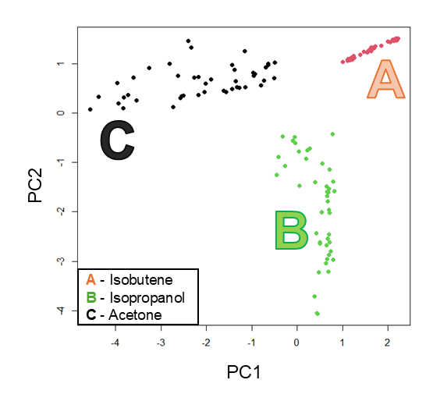
Figure 2: Principal Component Analysis of GC‑IMS responses obtained during Level 2 recognition tests performed according to the IEEE SA P2520.1 framework. The clear separation between the three reference compounds across different concentration levels and environmental conditions demonstrates the recognition capability of the instrument, with positive silhouette coefficients for all measurements.

    - Quantification assessment
Quantification capability was investigated following Level 3 (LVL3) procedures, using the mean absolute percentage error (MAPE) between instrumental response and nominal gas concentration. Under standard conditions, a consistent correlation between GC‑IMS signal features and reference concentrations was observed, supporting the feasibility of instrumental quantification within the tested range.
Variations in humidity were found to have a more pronounced impact on quantification accuracy than temperature changes, particularly at lower concentration levels. This effect can be attributed to humidity‑dependent ion mobility phenomena, which influence signal intensity and peak shape. Despite these limitations, quantification performance under combined environmental variations remained within acceptable ranges for most test conditions. These results indicate that, while quantification is more sensitive to experimental parameters than differentiation or recognition, it can be effectively addressed through standardized calibration protocols.
    - Applicability to commercial devices
The experimental results demonstrate that the IEEE SA P2520.1 classification framework can be successfully applied to commercial GC‑IMS devices without requiring hardware modification or proprietary calibration strategies. The use of predefined chemical classes and standardized performance metrics enables objective comparison between instruments and supports reproducible characterization across different laboratories.
From an industrial perspective, this approach facilitates the verification of electronic nose performance prior to deployment and provides a structured pathway for integrating instrumental odour monitoring into environmental control strategies. The results confirm the potential of standardized electronic nose classification as a complementary tool to conventional olfactometric methods.
    - Ongoing field validation and laboratory–field comparison
Building on the laboratory validation, an ongoing activity is extending the proposed framework to real‑world operational conditions. A commercial electronic nose system will be installed at the Mechanical Biological Treatment (STIR) facility of Battipaglia, where odour emissions constitute a significant environmental concern. Field measurements will be carried out in parallel with dynamic olfactometric analyses performed in accordance with EN 13725, enabling direct comparison between instrumental responses and sensory‑based odour concentration data.
In parallel, a twin electronic nose system will be classified in laboratory conditions following the IEEE SA P2520.1 protocol. This laboratory‑based characterization will serve as a reference baseline for interpreting field behaviour and assessing consistency between standardized instrumental classification and site‑specific odour monitoring. The combined laboratory–field approach is expected to contribute to the harmonization of instrumental and sensory methodologies and to support the practical adoption of electronic noses for continuous odour monitoring.
  - Conclusions
This work presents a research–industry collaborative approach to the standardized classification of electronic noses, addressing a key limitation in instrumental olfactometry related to the lack of reproducible and harmonized performance criteria. The application of the IEEE SA P2520.1 framework to a commercial GC‑IMS system demonstrated that differentiation, recognition, and quantification capabilities can be evaluated through fully instrumental procedures, without reliance on human sensory panels.
The results confirm that standardized laboratory protocols based on predefined chemical classes enable reproducible characterization of electronic noses and support objective comparison between devices. While quantification performance was found to be more sensitive to environmental parameters than differentiation and recognition, the observed limitations can be managed through controlled calibration strategies. Ongoing laboratory–field comparison activities further support the potential of the proposed framework to bridge standardized instrumental classification and regulatory odour assessment methodologies. Overall, the proposed approach represents a concrete step toward internationally shared standards for instrumental odour monitoring, facilitating continuous measurement and early detection of odour‑related critical events.
Acknowledgments
The experimental activities were partially supported by ENEA Proof of Concept funding. Extended methodological documentation is available as supporting technical material via Zenodo.
References

ENEA, 2025, Methods and measurements reporting according to IEEE SA P2520.1 draft standard, Technical Report, Zenodo, DOI: 10.5281/zenodo.19451759.

IEEE SA P2520.1, Draft, Standard for Baseline Performance of Odor Analysis Devices and Systems, Institute of Electrical and Electronics Engineers, New York, USA.

ISO/EN 13725, 2022, Air quality – Determination of odour concentration by dynamic olfactometry, European Committee for Standardization, Brussels, Belgium.

UNI 11761, 2023, Misurazione strumentale degli odori tramite IOMS, Ente Italiano di Normazione, Milan, Italy.

